Support for those affected by abuse in the Church
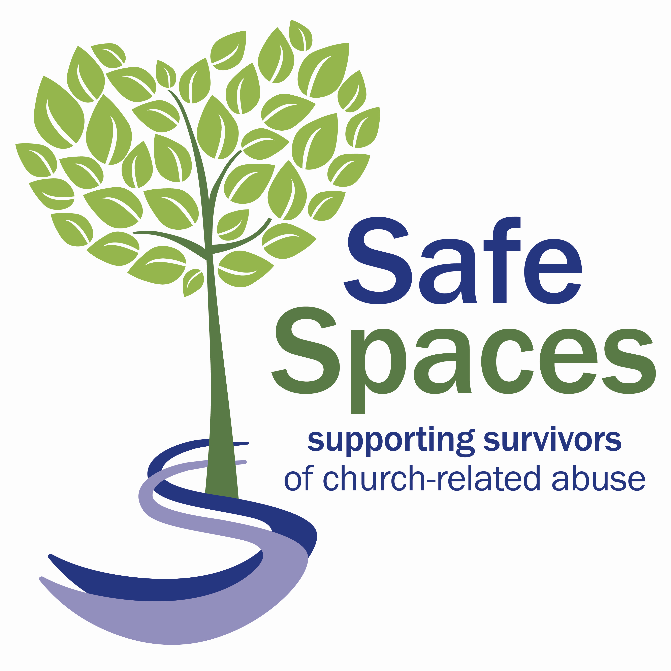

Safe Spaces is a free and independent support service for anyone who has experienced abuse in relation to the Church of England, the Church in Wales or the Catholic Church of England and Wales. This could be abuse by someone who holds any role at the church or is linked to participating in a church-led activity or group.

If you have been affected, however long ago, Safe Spaces can provide you with support. You do not have to have told the police or the church authorities, and you do not have to still be involved with the church. Your information will not be shared without your consent unless you or someone else is in immediate danger.

The Safe Spaces team is available through its helpline and live chat service between Monday-Friday 9am to 9pm, Saturday 9am-1pm and Sunday 1pm-5pm/

Tel: 0300 303 1056

Email: safespaces@firstlight.org.uk
Website:www.safespacesenglandandwales.org.uk

